
a
Company
Logotype

Cone Beam Computed Tomography- Report



Porur Dental X-rays & CBCT

Patient Name : Mr. Rama Rathnam | Date of Report : 29.06.2024
Age/ Gender : 60 years/ Male | Region of Interest : CBCT Maxilla
Referring doctor: Dr. Sasikumar | Indication : Implant assessment of 16, 17, 18.
Clinical Notes: Nil
PATIENT INFORMATION

CBCT- Maxilla provided
CBCT – IMAGE DETAILS

RADIOGRAPHIC INTERPRETATION

- Fractured crown: 16, 17.
- Root stumps: 28
- The maxillary alveolar ridge is present with normal trabecular pattern.
- Hyperdense screw like structure in relation to 26, 27.
- Presence of hyperdense restorative material within the pulp canal extending upto the apical region in relation to 25.

IMPLANT ASSESSMENT

 | 16 region | 17 region | 18 region
Sub-Crestal (in mm) | 7.85 | 11.2 | 12.03
Mid- Crestal (in mm) | 11.1 | 12.16 | 12.2
Distance between the alveolar ridge and floor of the maxillary sinus (in mm) | 17.03 | 13.44 | 13.28

RADIOGRAPHIC IMPRESSION

- Fractured crown: 16, 17.
- Root stumps: 28
- Implant in relation to 26, 27.
- Root canal treated tooth: 25

Kindly correlate with clinical findings


IMAGES FOR REFERENCE

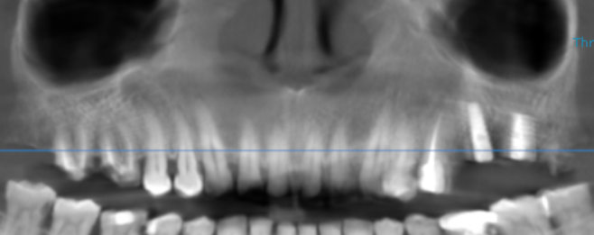
RECONSTRUCTED PANORAMIC VIEW

3-DIMENSIONAL VIEW

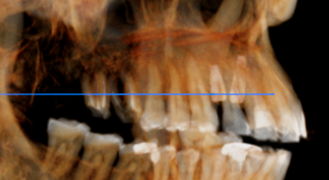

CROSS SECTIONAL VIEW

16 region | 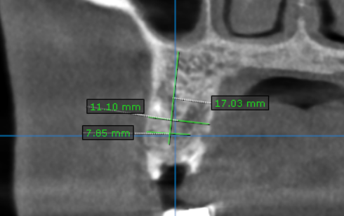
17 region | 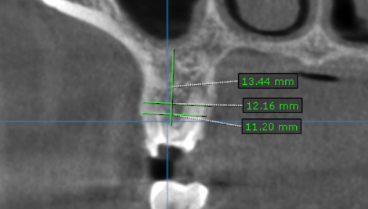
18 region | 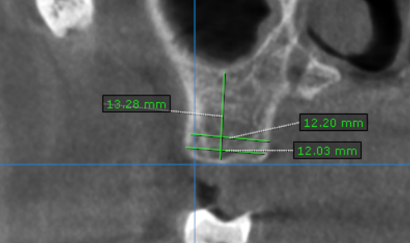

**** End of report ****

